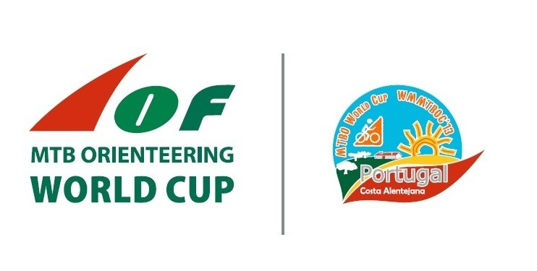 | World Cup Mountain Bike Orienteering  &  World Masters MTB Orienteering Championships  PRESS / MEDIA ACCREDITATION

Must be submitted till 01st August 2013 to WCUP office (e-mail: mtbo13.portugal@gmail.com)

Country:

Media type:

o Newspaper o Magazine o Radio o TV

Name of Publication/Company: ....................................................................................................................................................

Address: ....................................................................................................................................................

Phone: .................................. Fax: ................................. E-mail: ...............................................

Name of Representatives:
....................................................................................................................................................
....................................................................................................................................................
....................................................................................................................................................

Accommodation:

Please fill the “accommodation entry form” and submit to WCup office (see our web page).

Transport:

Please fill the “transport entry form” and submit to WCup office (see our web page).

Remarks:
………………………………………………………………………………………………………………………………………………………………………………………………………………………………………………………………………………………………………………………………………………………………………

Date: |  | Signature:

